**New**

**H** Oven-bake Potato Chips $4.00

**H** Oven-bake Potato Wedges $4.00 **V** Potato Jacket $4.00 **V** Spinach & Ricotta Triangles $4.00

**H** Grilled Chicken Burger/wrap/salad $5.50

**H** Butter Chicken with Rice $5.00

**(3.5 – 4.5) Sandwiches**

**All Sandwiches are made with Helga’s Bread**

**V** Salad (cheese, lettuce, tomato, cucumber, carrot) $4.00

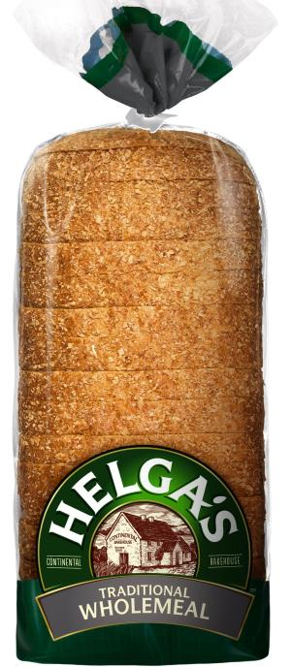Tuna Mix & Lettuce $4.50

**H** Chicken Lettuce & Mayo $4.50

**H** Chicken &Salad $5.00

**H** Chicken & Cheese $4.50

Ham & Salad $5.00

Ham Cheese & Tomato $4.50 **V**  Vegemite $3.00

**Add Extras**

Chicken/Ham - **$1,** Avocado **- $2.00**

Cheese/Beetroot - **50c**

**Fresh/Toasted Wraps**

**V** Plain Salad Wrap $4.00

**H** Chicken Strip, Lettuce & Mayo Wrap $4.50

**H** BBQ Chicken Strip Wrap $4.50

**H** Sweet Chilli Chicken Strip Wrap $4.50

**H** Chicken & Salad Wrap $5.00

Ham & Salad Wrap $5.00

**Add Extras**  Chicken/Ham - **$1,** Avocado **- $2.00**

**Toasties**

**All Toasted Sandwiches are made with Helga’s Bread**

**V** Cheese Toasted Sandwich $3.50

Ham & Cheese Toasted Sandwich $4.00

**H** Chicken & Cheese Toasted Sandwich $4.50

**Add Extras**  Chicken/Ham - **$1,** Avocado **- $2.00**

**Sushi & Salads**

Tuna Sushi $3.00

Garden Salad with Cheese $4.50

Greek Salad with Feta $4.50

Tuna & Salad $4.50

**H** Chicken & Salad $5.00

**H** Ham & Salad $5.00

**Add Extras** Avocado **- $2.00,** Feta,Beetroot - **50c**

**Fruit & Yoghurt**

Piece of fruit (apple, mandarin or banana) $1.00

**j0424836**Watermelon Triangle $1.00Fruit Salad Cup $2.50Two Fruit Snack $2.00 Yoghurt with Granola $3.00

Fruit Kebab Stick $1.50

**Frozen Snacks**

Streets Ice Cream $2.50

Frozen Juice Cup $1.00

Flavoured Slushies **(over the counter only)** $2.50Ice Mony $1.50

**All meal deals come with free fruit**

|  |  |
| --- | --- |
| **Meal Deal 1 - $6.50**  Butter Chicken w’ Rice  250ml fruit juice | **Meal Deal 2 - $6.50**  Greek Salad  600ml Bottled Water |
| **Meal Deal 3 - $6.50**  Fried Rice  250ml fruit juice | **Meal Deal 4 - $6.50**  Chicken Breast Burger  Chill J Drink |

**Hot Food**

**H** Chicken Burger $5.00

**H** Beef Burger with Salad or Cheese $5.00

**H** Chicken Breast Burger $5.50

**H** Chicken Kebab Stick $3.50 **H** Chicken Nuggets $3.50 **H** Chicken Chippies $4.00

**H** Crumbed Fish Fingers (I&J) $3.00

**V** Garlic Bread $1.50

**V** Cheesy Garlic Bread $2.00

**Pastries & Sauce**

**H** Meat Pie $4.00

**H** Steak & Potato Pie $4.50

**H** Sausage Roll $3.50

**Tomato / BBQ 50c**

**Pasta, Pizza, Rice**

**H** Fried Rice $4.00

**H** Butter Chicken & Rice $5.00

**H** Beef Lasagne $5.00

**H** Spaghetti Bolognaise $4.50

**V** Macaroni & Cheese $5.00

**V** Cheese Pizza $4.00

**H** BBQ Chicken Pizza $4.50 Noodles Chicken / Beef $3.50

**Drinks**

300ml Pura Plain Milk $1.50

****300ml Oak Flavoured Milk $2.50

Up & Go Breakfast Drink $3.00

Plain Milk w/Sipahh Straw $2.50

Harvey Juice (Apple,Orange) $2.50

600ml Bottled Water $2.00

Chill J 250ml $2.50

Hot Chocolate **(0ver the counter only)** $2.50

**Snacks**

Cheese & Biscuits $1.00

Veggie Sticks & Dip $2.50

Salad Shaker $2.00

Popcorn $1.50

Choc Custard $1.50

Banana Bread $1.50

**H** Jelly $1.50

Red Rock Deli Sea Salt Chips $2.00

**Breakfast**

Corn Flakes or Nutri Grain w/milk $2.00

Vegemite Toast 50c

Raisin Toast 50c